**PUBLIC TRANSPORT OPTIMIZATION**

**PHASE 3 SUBMISSION**

**TEAM MEMBERS:**

SANJAYKUMAR. S

NANDHAKUMAR. M

NISANTH. U

SHRIHARIHARAN. C

MANIVEL. S

**MENTOR:**

PROF. PRABHU

**CODE FOR WEBSITE:**

<!DOCTYPE html>

<html>

<head>

<title>Vehicle Essentials and Navigation</title>

<link rel="stylesheet" type="text/css" href="styles.css">

</head>

<body>

<header>

<h1>Welcome to Vehicle Essentials</h1>

<nav>

<ul>

<li><a href="#">Home</a></li>

<li><a href="#">Vehicles</a></li>

<li><a href="#">Contact</a></li>

</ul>

</nav>

</header>

<main>

<section>

<h2>Featured Vehicles</h2>

<div class="vehicle-listing">

<h3>Vehicle 1</h3>

<p>Details about Vehicle 1.</p>

</div>

<div class="vehicle-listing">

<h3>Vehicle 2</h3>

<p>Details about Vehicle 2.</p>

</div>

</section>

<section>

<h2>Search for Vehicles</h2>

<form>

<label for="search">Search:</label>

<input type="text" id="search" name="search">

<input type="submit" value="Submit">

</form>

</section>

</main>

<footer>

&copy; 2023 YourWebsiteName

</footer>

</body>

</html>

CSS:STYLE

body {

font-family: Arial, sans-serif;

}

header {

background-color: #333;

color: #fff;

text-align: center;

padding: 10px;

}

nav ul {

list-style: none;

}

nav ul li {

display: inline;

margin-right: 20px;

}

main {

padding: 20px;

}

.vehicle-listing {

border: 1px solid #ddd;

padding: 10px;

margin: 10px 0;

}

footer {

background-color: #333;

color: #fff;

text-align: center;

padding: 10px;

}

JAVASCRIPT FOR COMPLETEING A WEBSITE

// Importing classes from java.servlet package

// for connectivity of application class

import javax.servlet.ServletException;

import javax.servlet.annotation.WebServlet;

import javax.servlet.http.HttpServlet;

import javax.servlet.http.HttpServletRequest;

import javax.servlet.http.HttpServletResponse;

// Since userlogin is used in action="userlogin"

// form tag in jsp page

@WebServlet("/userlogin")

// Class 1

// Helper class extending HttpServlet main class

public class LoginServlet extends HttpServlet

{

// Method

@Override

protected void doPost(HttpServletRequest request,

HttpServletResponse response)

throws ServletException, IOException

{

response.setContentType("text/html");

PrintWriter out = response.getWriter();

// Customly setting name and password

String name = request.getParameter("name");

String password = request.getParameter("password");

....

// Further programming

// Code can be appended here onward so

}

}

let currentIndex = 0;

const images = document.querySelectorAll('#slideshow img');

function nextSlide() {

images[currentIndex].style.display = 'none';

currentIndex = (currentIndex + 1) % images.length;

images[currentIndex].style.display = 'block';

}

setInterval(nextSlide, 3000); // Change slide every 3 seconds

const form = document.getElementById('myForm');

form.addEventListener('submit', function (event) {

const nameInput = document.getElementById('name');

const emailInput = document.getElementById('email');

if (nameInput.value === '' || emailInput.value === '' || !emailInput.checkValidity()) {

alert('Please fill in the form correctly.');

event.preventDefault();

}

});

function changeText() {

const demo = document.getElementById('demo');

demo.innerHTML = 'Text has changed!';

}

SAMPLE DESIGN:

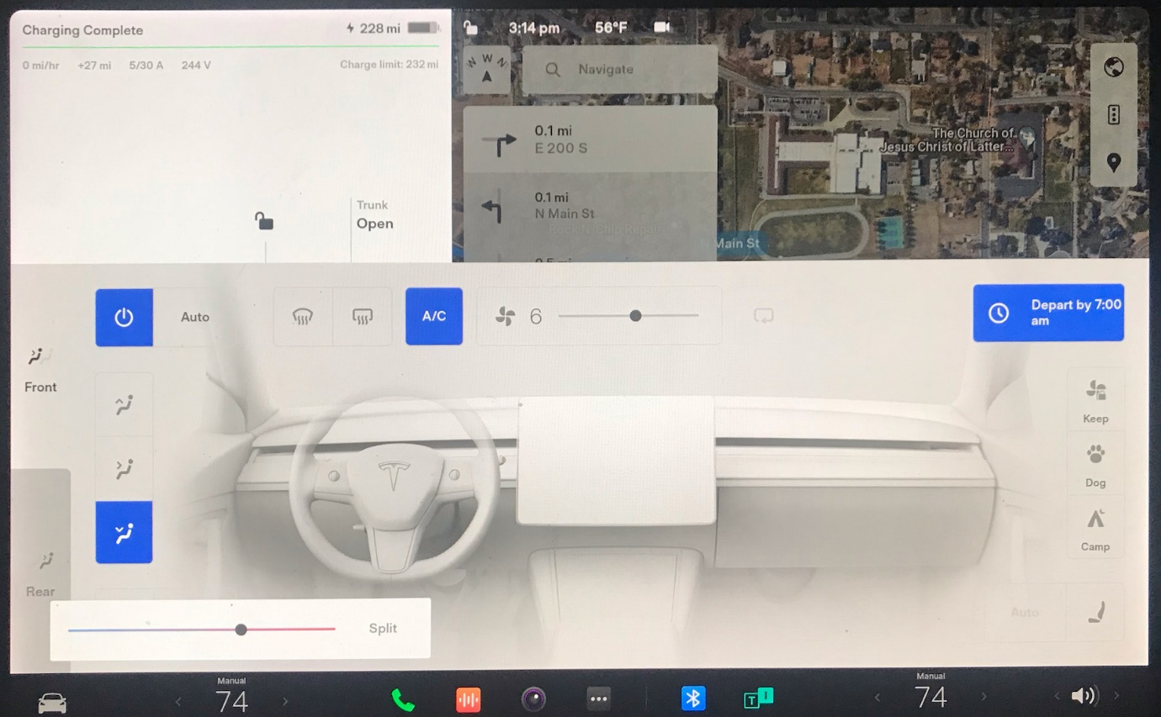

SAMPLE WEB PAGES:

